APPR6312 POE PART 1

Darshan Pyda
ST10278170

Table of Contents
Project Azure DevOps Page – Section A 2
Backlogs Page (Epic’s, Features, User Stories & Tasks) 4
Backlogs Page Picture 2 5
Backlogs Page Picture 3 6
Backlogs Page Picture 4 7
Board Page 8
Explanation on sprint goals and prioritization 9
Sprints Main Page 10
Release 1 – Sprint (Week 1-2) 11
Release 2 – Sprint (Week 3-4) 12
Release 3 – Sprint (Week 5-6) 13
Azure SQL Server Database – Section B 14
Resource Group Picture 15
SQL Server Networking 16
New Firewall Rule Picture 17
SQL Database Connection to Azure DevOps 19
ERD Diagram Tables 0
Business Rules of the ERD Diagram 0
SQL Tables 2
Short Explanations on Efficiency, Scalability and Integrity 7
Bibliography 8

Project Azure DevOps Page – Section A
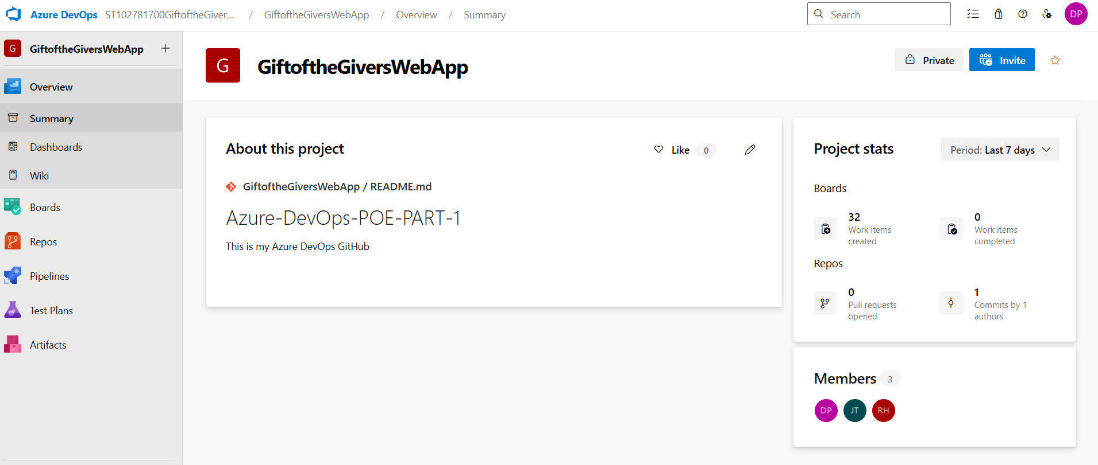
This is the Home Page, creation of GiftoftheGivers Website Project Planning.
Here the GitHub link and README. File is visible alongside the Team Members and Project Stats (Both on the Right-Hand Side).
Team Members Page
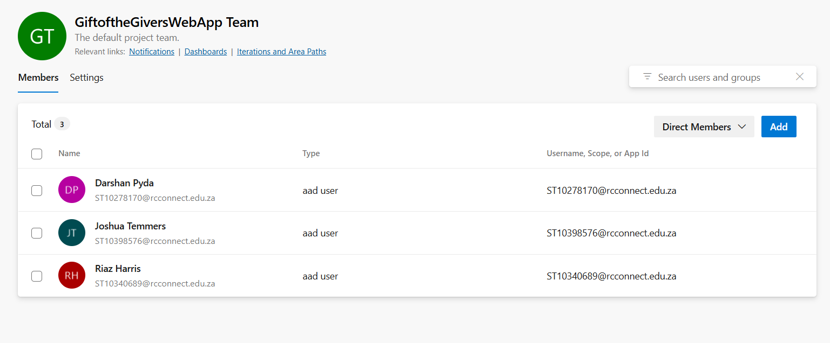
For the Teams Members, by default it is only me, however I have placed some members here just for task duty.

Backlogs Page (Epic’s, Features, User Stories & Tasks)
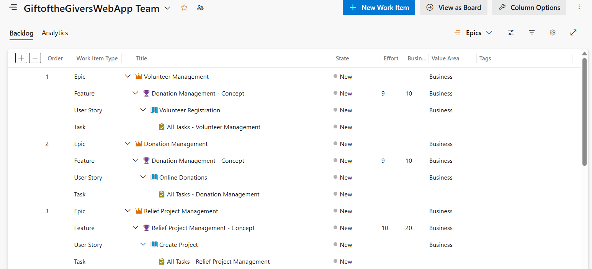
On this specific page, I am only showing 3 EPIC’s, 3 FEATURE’S , 3 USER STORIES and 3 TASKS each Individually.
I have a total of 7 EPIC’s, more pictures displayed below;

Backlogs Page Picture 2
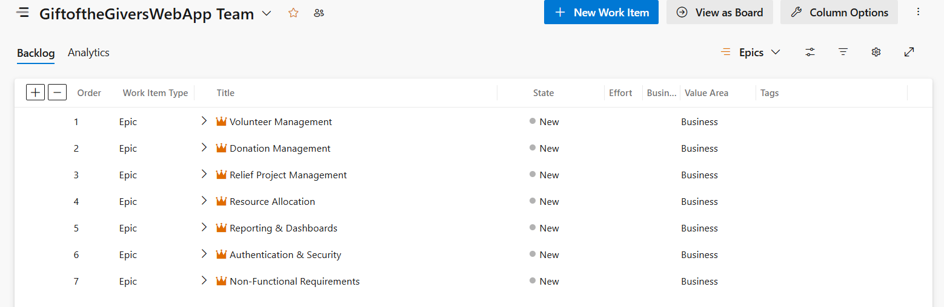
The other four EPIC’s namely;
4 – Resource Allocation
5 – Reporting & Dashboards
6 – Authentication & Security
7 – Non-Functional Requirements

Backlogs Page Picture 3
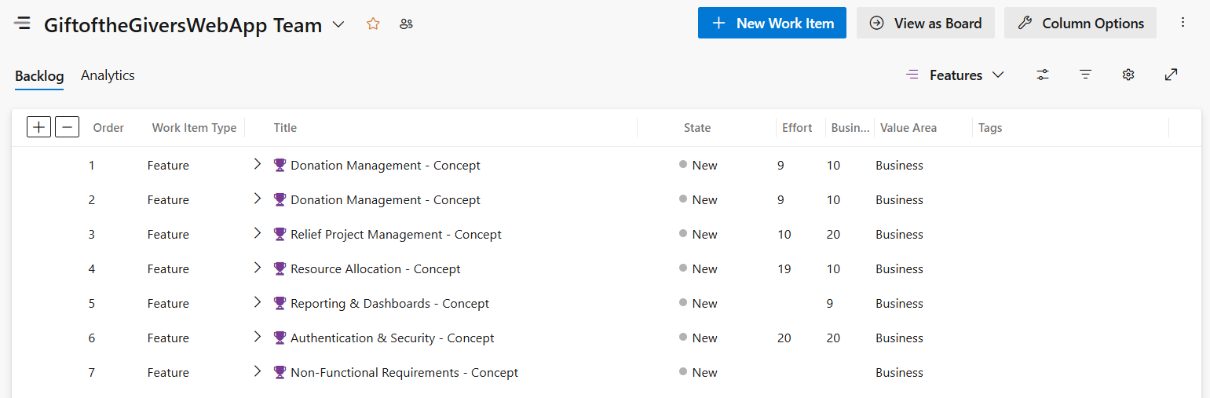
The other four Feature’s namely;
4 – Resource Allocation – Concept
5 – Reporting & Dashboards – Concept
6 – Authentication & Security – Concept
7 – Non-Functional Requirements – Concept

Backlogs Page Picture 4
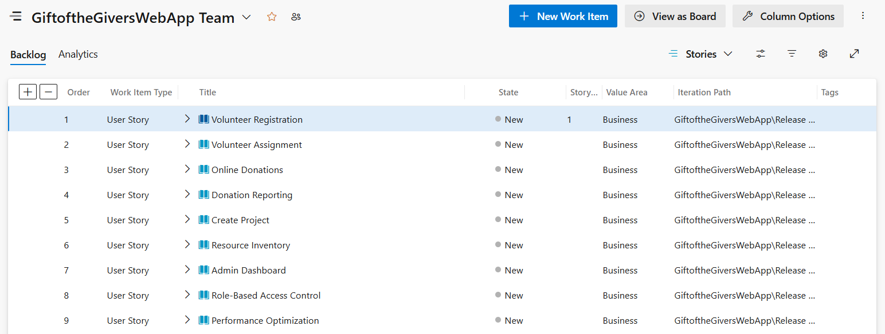
On this page, I have 9 USER STORIES, some of the EPIC’s have one or more User Stories placed as sub-categories.
These are all the pre-requisites before task handling and allocations.
As shown on the Right-Hand Side, the Iterations are either phased by (Sprint 1 – Sprint 3), (Week 1 – 6).

Board Page
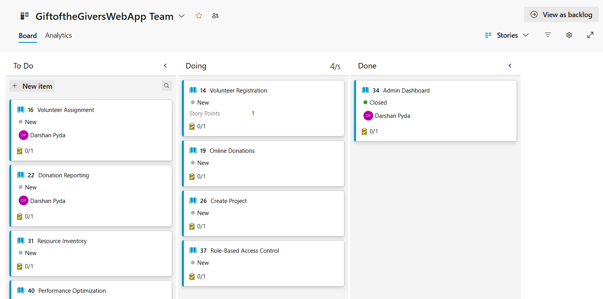
Screenshot of Board.

Explanation on sprint goals and prioritization
Sprints Goal 1: This goal firstly focuses on Authentication & Security, Volunteer Management and Donation Management, ensuring that security role-based access control and registration is secure, for volunteer management, all potential users can sign up with relevant contact info, skills and availability on each profile for maintenance and documentation upload. Lastly for Donations Processing, an access profile with payments gateway creation and final receipt invoice plus confirmation email.
Prioritization Level: High Priority (Immediate Effect) – Authentication & Security, Volunteering Registrations and lastly Donations Processes.

Sprints Goal 2: This goal focuses on Relief Management and Resource Inventory, ensuring that all projects are created and tracked by means of location, needs and status, along with volunteers to each individual project. As for the Inventory all in & out supplies need tracking and stock levels maintenance is a must for GiftoftheGivers.
Prioritization Level: Medium Priority (Secondary Effect) – Relief Project Management and Resource Inventory.

Sprints Goal 3: This goal focuses on Reporting & Dashboards and Non-Functional Requirements, ensuring that dispatch planning is on schedule and all deliverables are tracked with supplies. As for other dashboards and exports, plus any non-functional requirements like basic security measures.
Prioritization Level: Low Priority (Third Effect) – Reporting & Dashboards and Non-Functional Requirements.

Sprints Main Page
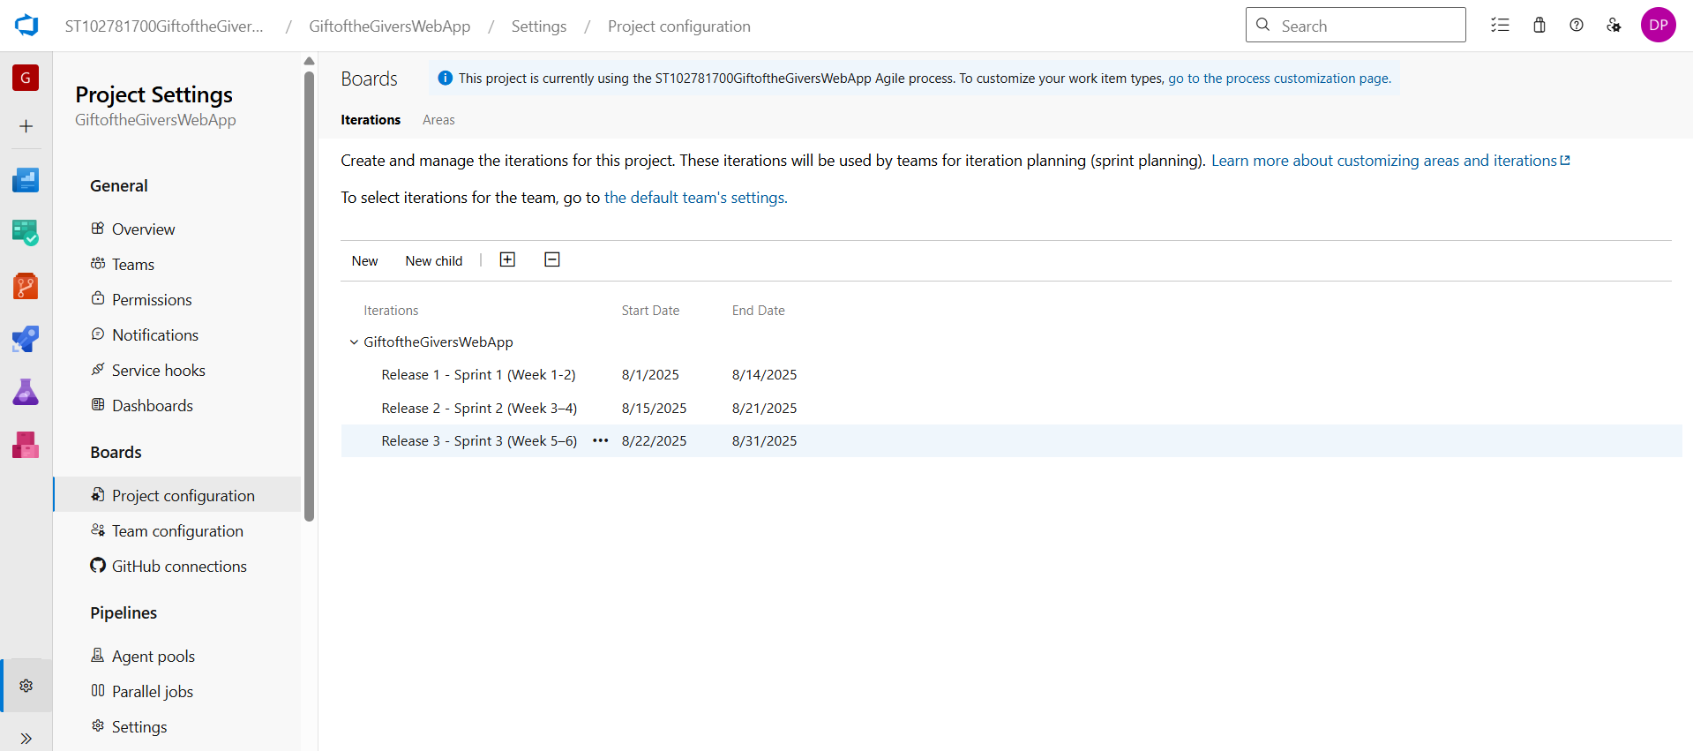
In the above image, we can see the Sprints tier created, namely;
Release 1 – Sprint (Week 1-2) & Release 2 – Sprint (Week 3-4) & Release 3 – Sprint (Week 5-6)

Release 1 – Sprint (Week 1-2)
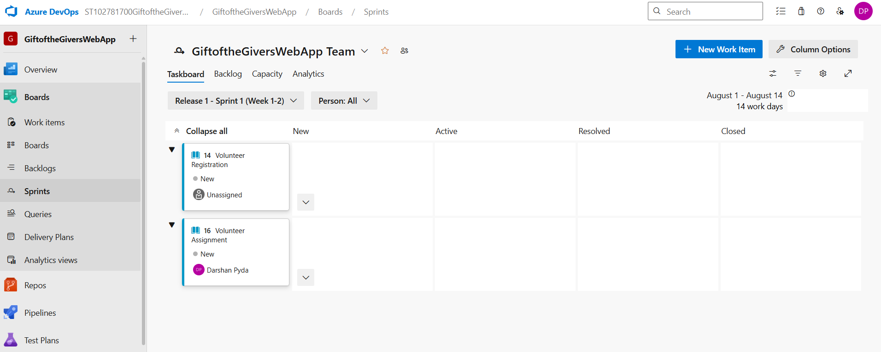
The start of the first Sprint is from the 1^{st of} August – 14th August as seen on the right-hand side of the image. There are two tasks that are needed to be completed in the first Sprint, both of which fall under the Volunteer Management EPIC. Specifically, the Registration Task and Assignment Task.

Release 2 – Sprint (Week 3-4)
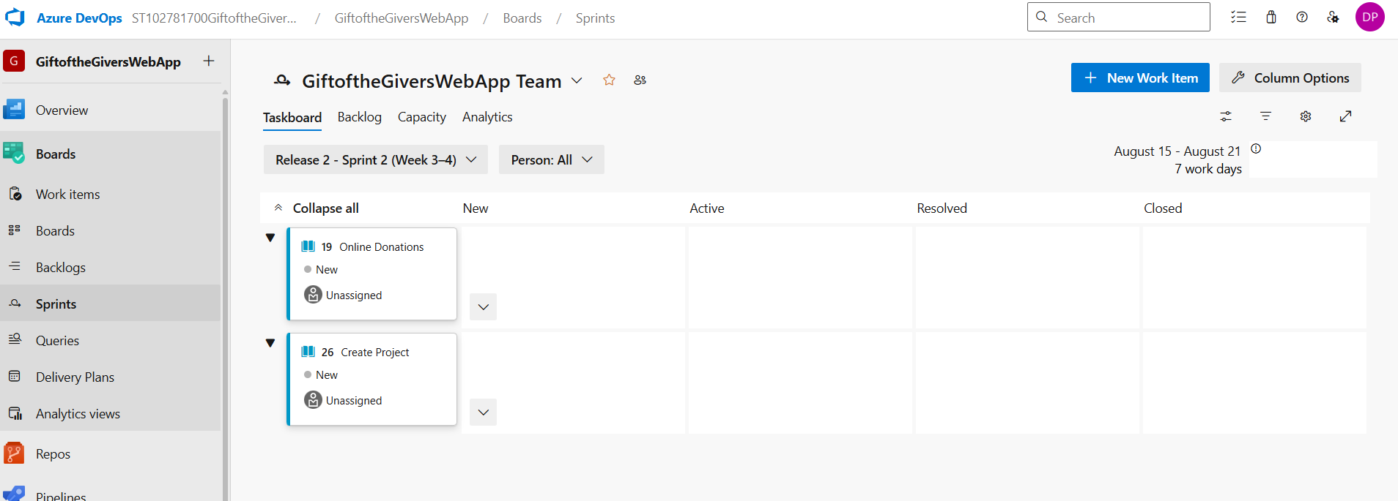
The start of the second Sprint is from the 15^{th of} August – 21st August as seen on the right-hand side of the image. There are two tasks that are needed to be completed in the second Sprint, both of which fall under the Online Donations and Project Management EPIC. Specifically, the Online Funding Task and Create Project Task.

Release 3 – Sprint (Week 5-6)
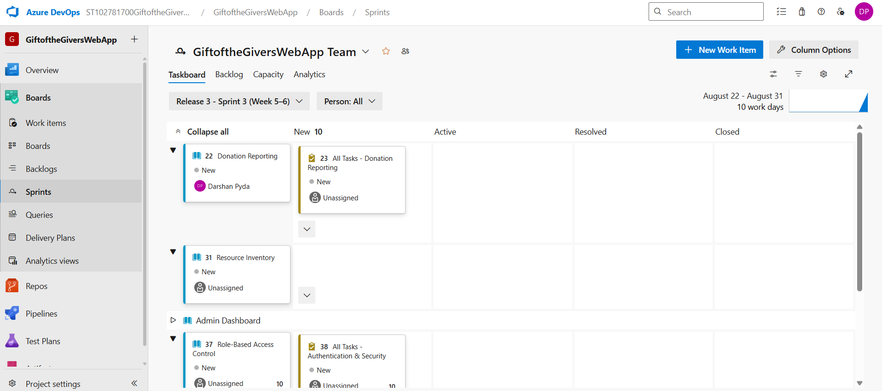
The start of the third and last Sprint is from the 22^{nd of} August – 31st August as seen on the right-hand side of the image. There are two tasks that are needed to be completed in the last Sprint, both of which fall under the Online Donations, Resource Management, Inventory and Security Authentication EPIC. Specifically, the Online Reporting Task, Inventory Task and Role-based Task.

Azure SQL Server Database – Section B
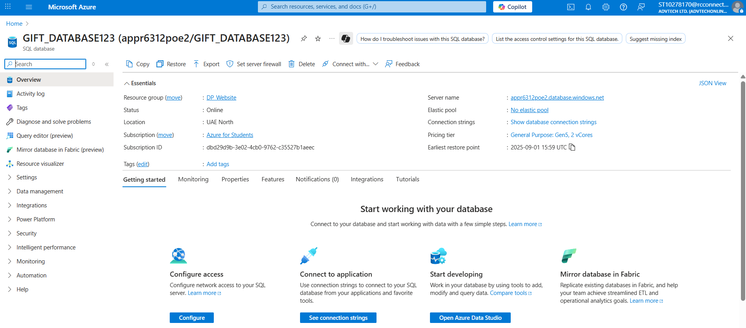
This is an image of the Home SQL Server Database on Azure DevOps. The name of my database is GIFT-DATABASE123, and I make use of a server called appr6312poe2.database.windows.net for an SQL 2019 authentication log in.

Resource Group Picture
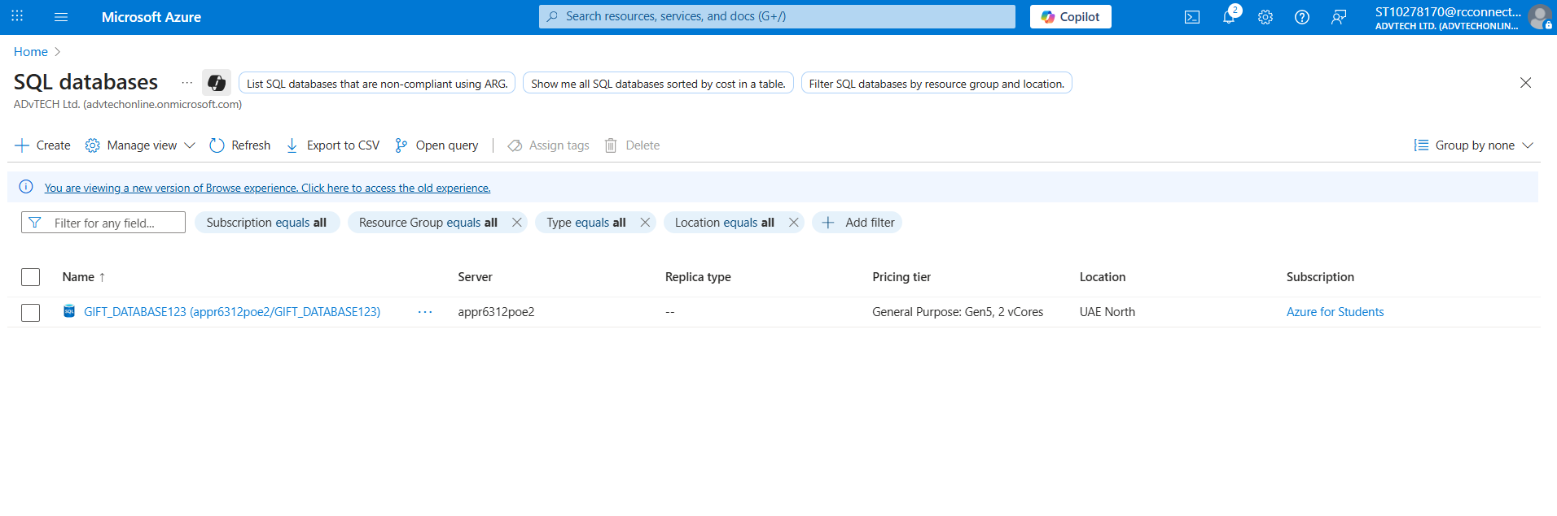
As shown here I have only created one specific database to match the requirements of the GiftoftheGivers project plan initiative.
Namely; GIFT-DATABASE123.

SQL Server Networking
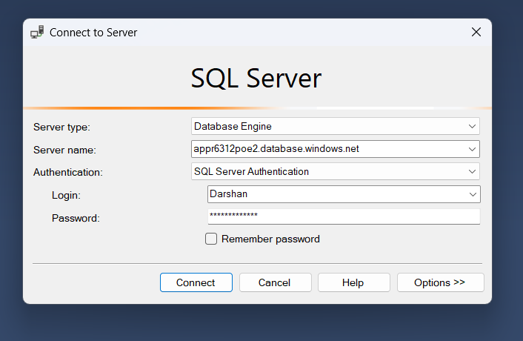
The above picture shows the connection to SQL Server using the created server name: appr6312poe2.database.windows.net
and admin who is Darshan. Below are more pictures with explanations on the SQL firewall networking.

New Firewall Rule Picture
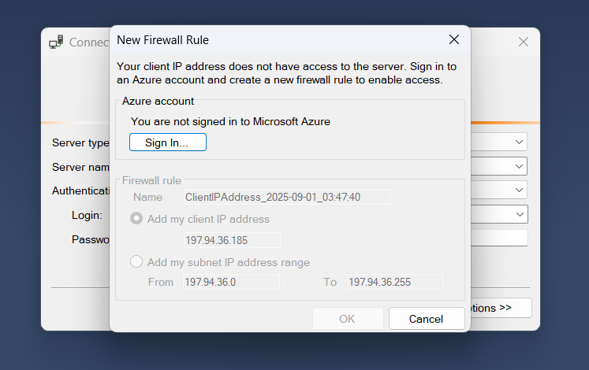
Once connected to SQL Server a Sign-in to Microsoft Azure is required to link the Client IP Address.

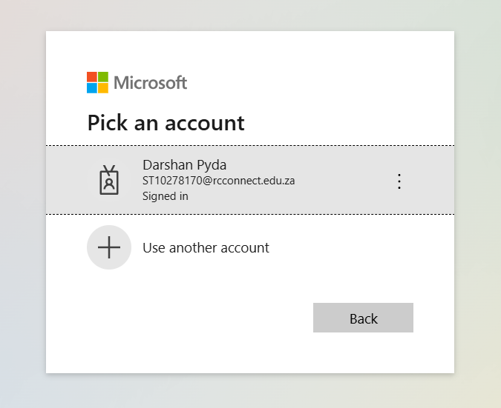
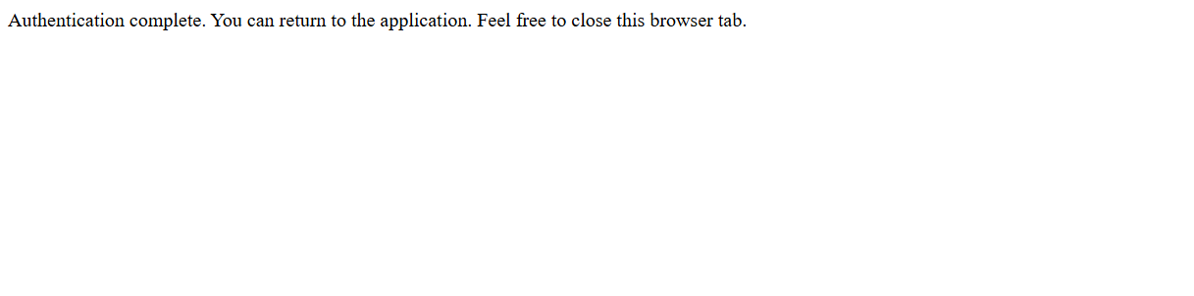
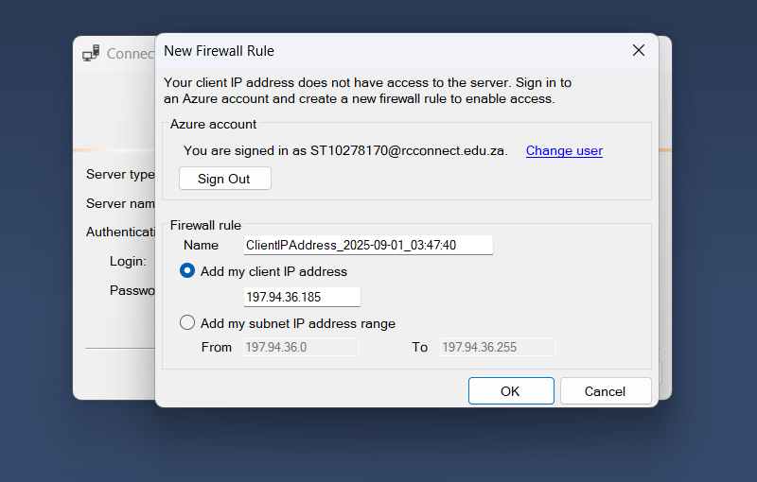
In the above pictures, the registration to Microsoft is successful and once the Authentication is completed, the New Firewall Rule allows for Azure DevOps to work on SQL 2019 Server.

SQL Database Connection to Azure DevOps
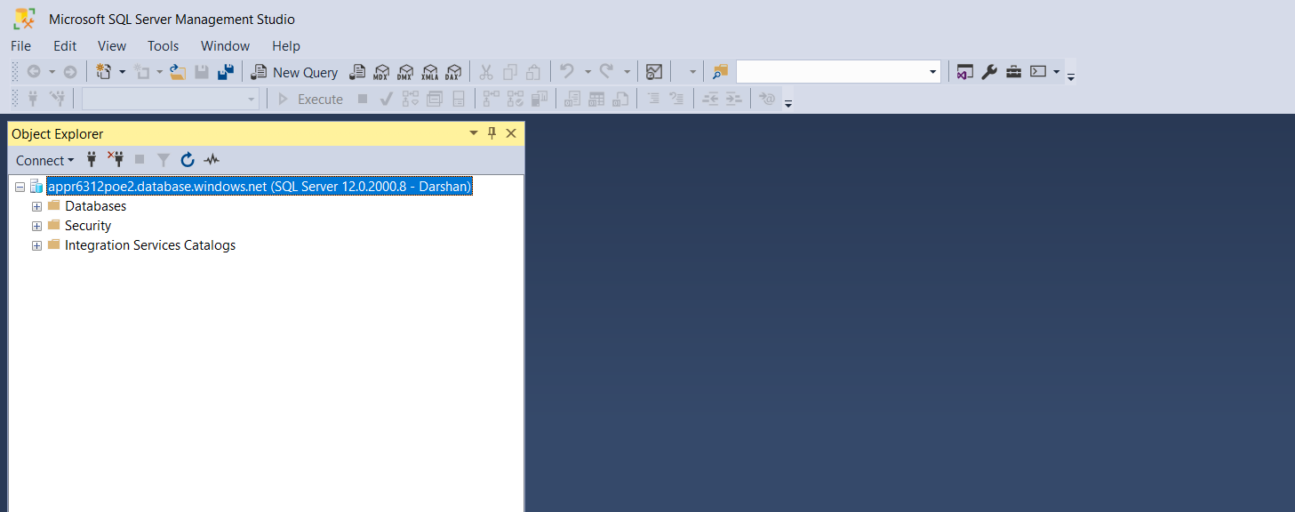
Here in the above picture the Azure SQL database is connected successfully to SQL 2019.
Which allows for the tables creation of Identify entities: Users, Volunteers, Incidents, Projects, Donations, under groups of data placements in different table names, multiple columns, many data types and singular primary keys.

ERD Diagram Tables
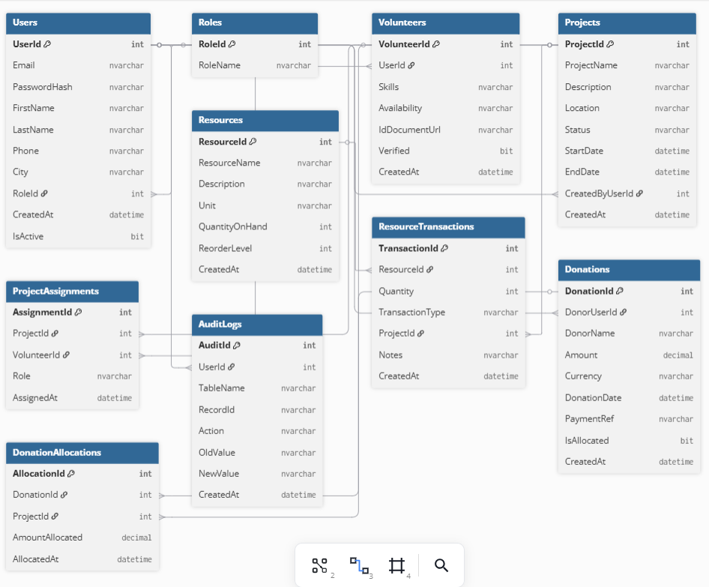
This is the ERD Diagram based on the SQL Tables.

Business Rules of the ERD Diagram
Users & Roles
- Each User must belong to one specific role like an Admin, Volunteer or Donor.
- A Role duty can belong to multiple Users.
- Business Rule = Each User has one role, but roles can be given to many Users.
Users & Volunteers
- A Volunteer is linked to a User.
- Not all Users are volunteers like donors and admins in particular.
- Business Rule = A Volunteer is a user, but not all the users are Volunteers.
Projects & Users
- All Projects are created by users like the owner or specific creator.
- A User can have many Projects.
- Business Rule = Projects created by users, but Users can create multiple projects.
Volunteers & Projects
- Volunteers can have many project designations.
- Each individual project has multiple Volunteers.
- (Many-to-Many relationship, implementation by ProjectAssignments).
- Business Rule = Volunteers assigned to many projects, but projects may include many volunteers.

Resources & Projects
- Resources like equipment, supplies, inventory are not limited to projects but through ResourceTransactions.
- Projects can use many resources, and a type/range of resources can be utilized in multiple projects.
- Business Rule = Resources are used or given to projects through certain transactions.
Donations & Users
- Donations are given by many Users.
- A single user may fund many donations.
- Business Rule = Users can make many donations, but each individual donation belongs to specific users only.
Donations & Projects
- Donations are provided to projects through DonationsAllocations.
- Donations are divided across many projects.
- Projects can be funded through single/many donations.
- Business Rule = Donations are allocated to single/more projects, but projects receive funding from multiple donations.
Audit Logs & Users
- All Audits belong to a User who done the work.
- Business Rule = All activities are logged alongside the person/user, whom details are either old or new.

SQL Tables
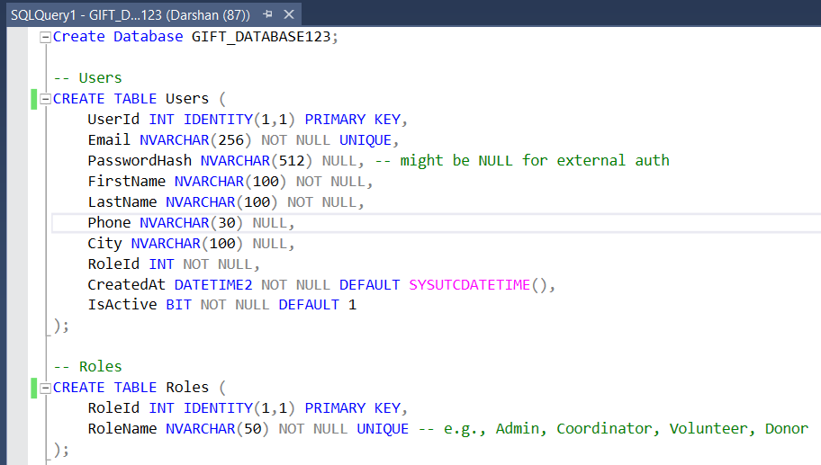
In the above picture is the Data Type Users and Roles, as two different tables are created from them each and with their own primary keys and other necessary attributes for the GiftoftheGivers Project Website. Also the Database was created at the top of the picture.

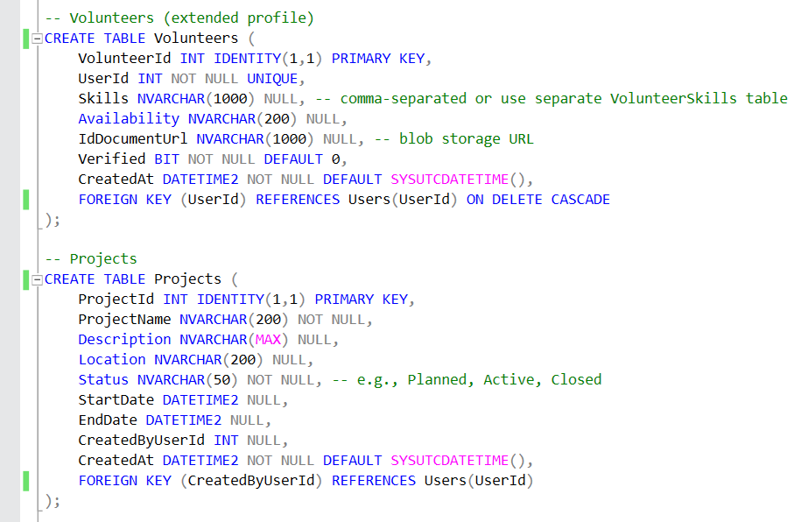
Here we have the Project and Volunteers Data Types each with its own tables and attributes required.

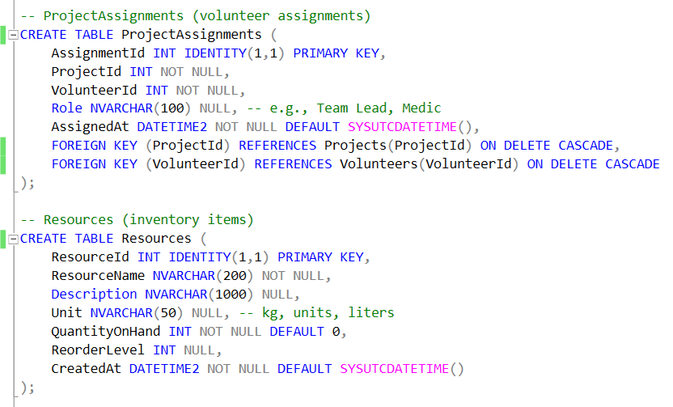
Here we have the Resources and ProjectAssignments Data Types and table attributes required.

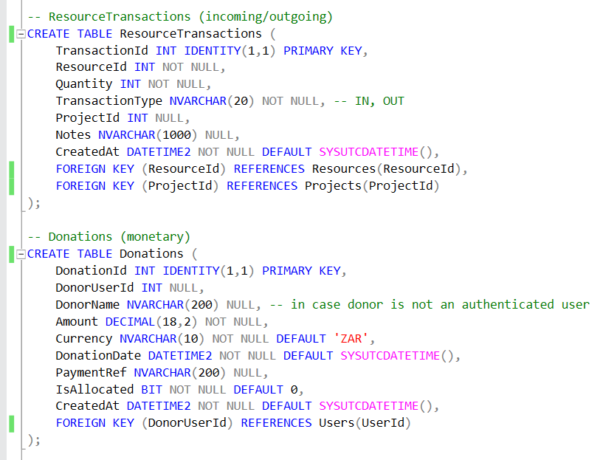
Here we have the Donations and ResourceTransactions Data Type, and table attributes required.

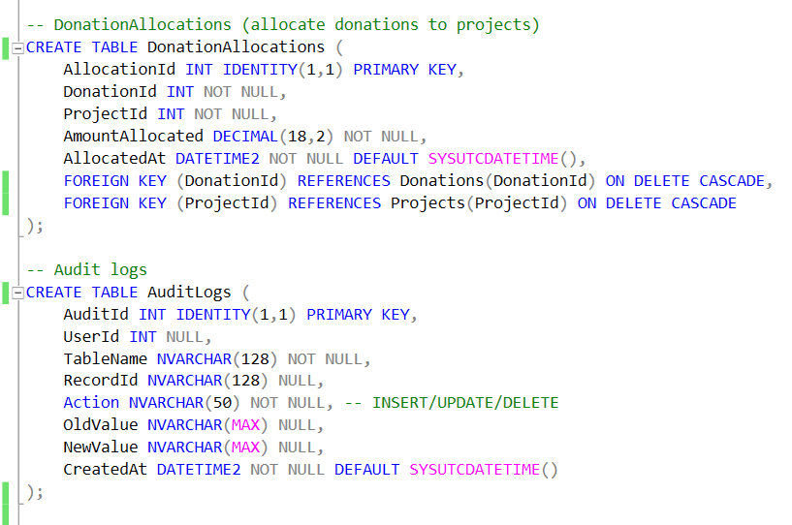
Here we have the AuditLogs and DonationsAllocations Data Type, and table attributes required.

Short Explanations on Efficiency, Scalability and Integrity
Efficiency – refers to the best way to maximise the use resources in anything, in terms of this case we refer to how the task was completed, maintained, backed by evidence and relevant to importance of project management aspects of GiftoftheGivers Website and Azure DevOps Database.

Scalability – refers to the ability of any system or performance increase in relation to something, in terms of this case we refer to how the standard of work is in relation to the basic settings of GiftoftheGivers website and any related data usage.

Integrity – refers to accurate whole and unchanged information which is primarily trustworthy and follows-up continuously, in terms of the case according to GiftoftheGivers Project Management plans, we focus on real facts, functions and raw data from our sources provided below.

Bibliography
interns, H., 2018. dbdiagram.io.com. [Online]
Available at: https://dbdiagram.io/d/68b744f9777b52b76cc00270
[Accessed 2 September 2025].
Jain, S., 2008. GeeksforGeeks.com. [Online]
Available at: https://www.geeksforgeeks.org/system-design/balancing-efficiency-and-scalability-1/
[Accessed 2 Septtember 2025].
Jain, S., 2008. GeeksforGeeks.com. [Online]
Available at: https://www.geeksforgeeks.org/ethical-hacking/information-security-integrity/
[Accessed 2 September 2025].
Microsoft, 2008. Azure DevOps Project. [Online]
Available at: https://dev.azure.com/ST102781700GiftoftheGiversWebApp/GiftoftheGiversWebApp
[Accessed 2 September 2025].
Microsoft, 2008. Azure DevOps SQL Database. [Online]
Available at: https://portal.azure.com/#@advtechonline.onmicrosoft.com/resource/subscriptions/dbd29d9b-3e02-4cb0-9762-c35527b1aeec/resourceGroups/DP_Website/providers/Microsoft.Sql/servers/appr6312poe2/databases/GIFT_DATABASE123/overview
[Accessed 2 September 2025].
N, M. S., 2016. APPR6312_POE_PART1_GUIDE. [Online]
Available at: https://acrobat.adobe.com/id/urn:aaid:sc:EU:b0c053f4-1d9f-465e-a792-0935db8e6bea
[Accessed 2 September 2025].
Sooliman, D. I., 1992. Gift-of-the-Givers. [Online]
Available at: https://giftofthegivers.org/
[Accessed 2 September 2025].
Tom Preston-Werner, C. W. P. J. H. a. S. C., 2007. GitHub.com. [Online]
Available at: https://github.com/ST10278170/Azure-DevOps-POE-PART-1
[Accessed 2 September 2025].

